**Lesson 04 Demo 05**

**Implementing Generative AI in Framer for**

**E-commerce Prototyping**

**Objective:** To efficiently prototype and visualize web designs of an e-commerce website using Framer

**Tools required:** Framer

**Prerequisites:** NA

Steps to be followed:

1. Use Framer to generate a responsive webpage
2. Enhance UI design for the generated page

**Note:** Access framer using this link - **https://www.framer.com/**  
Generative AI tool used in this exercise can produce varied outputs even when presented with similar prompts. Thus, you may get different output for the same prompt.

**Step 1: Use Framer to generate a responsive webpage**

* 1. Navigate to the Framer website and click on **Open Framer** to access the Framer workspace

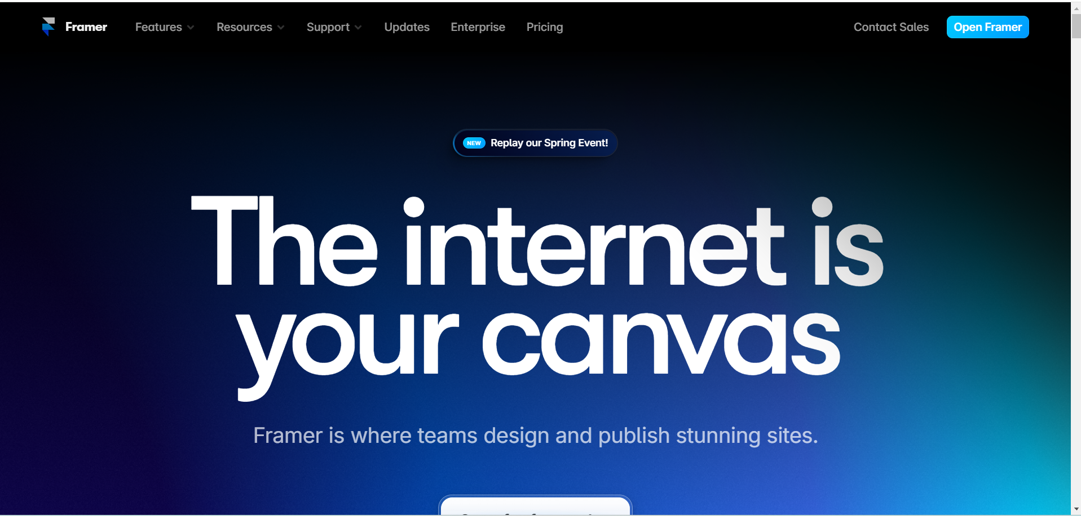

* 1. Click on **New Project** to create a new one

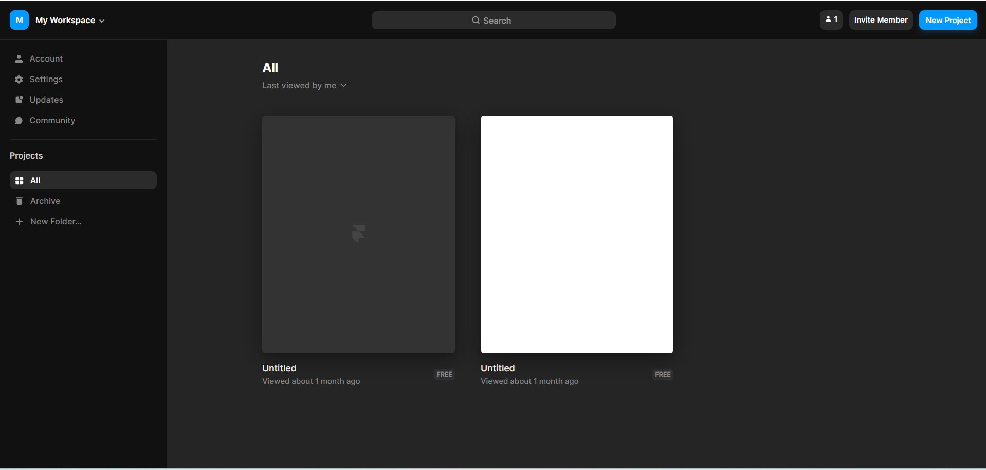

The untitled workspace for the new project appears as follows:

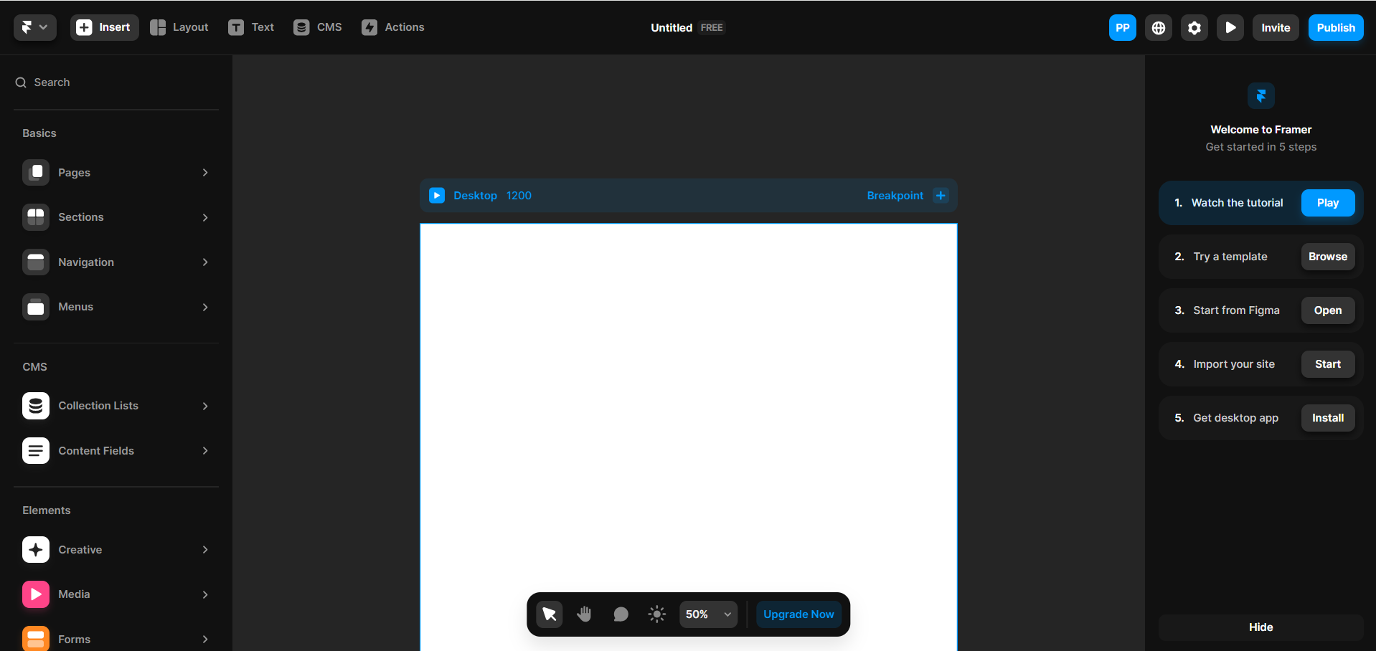

* 1. Rename the project to **E-Commerce**

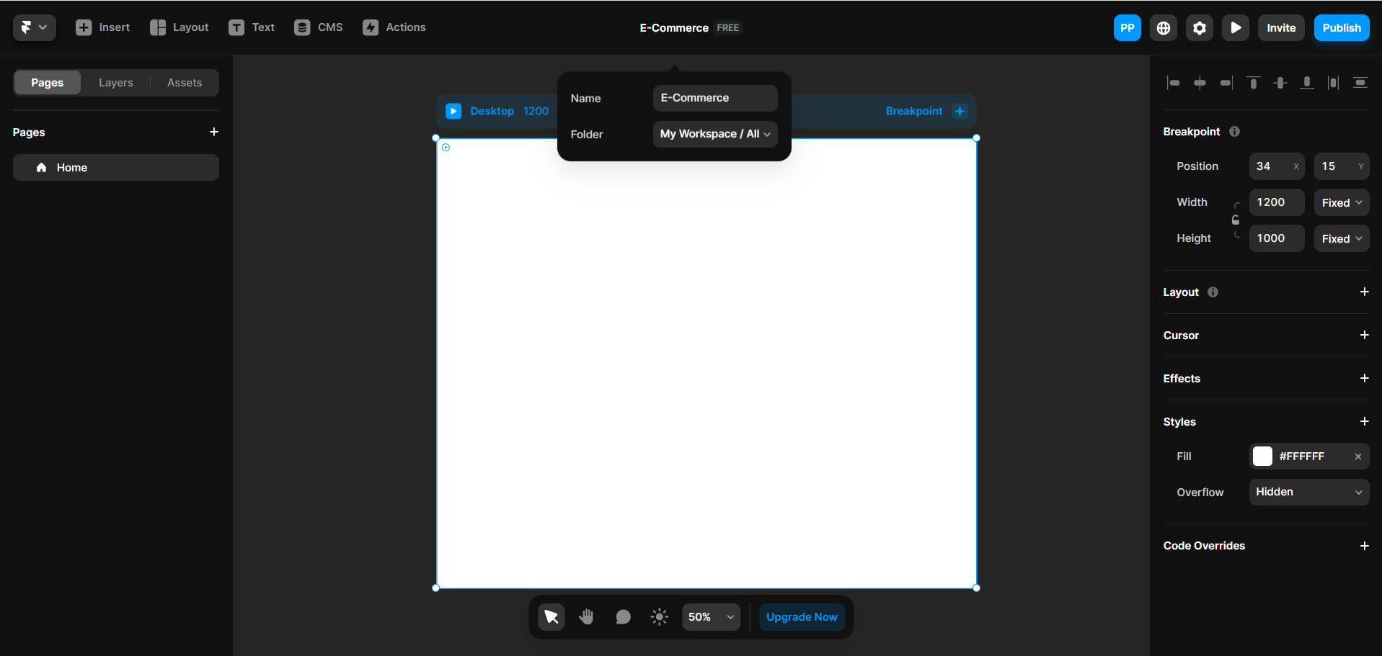

You will see the following interface:

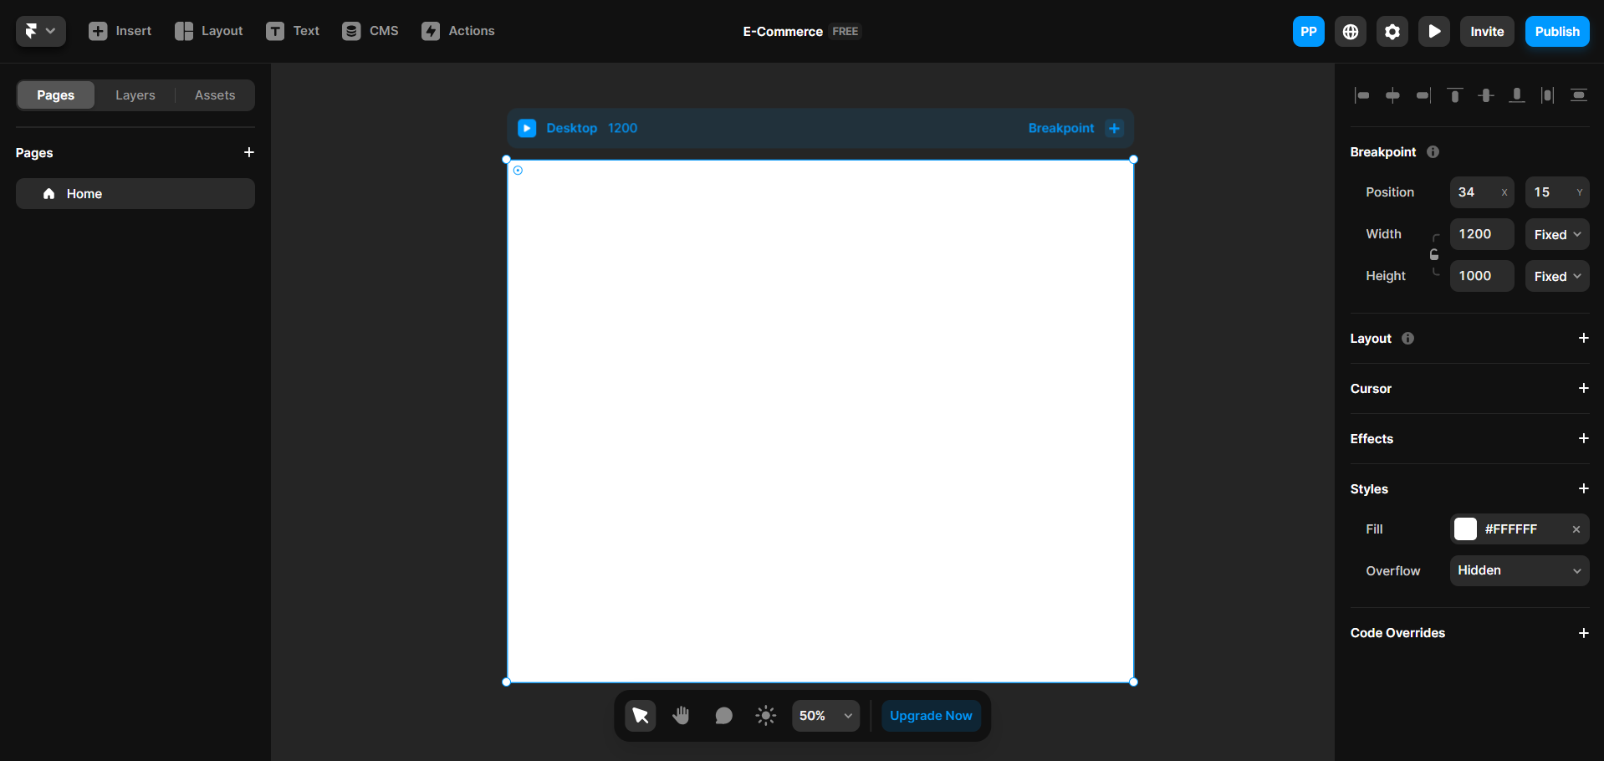

* 1. Click on the **+** icon and select **New Page** to create a new page

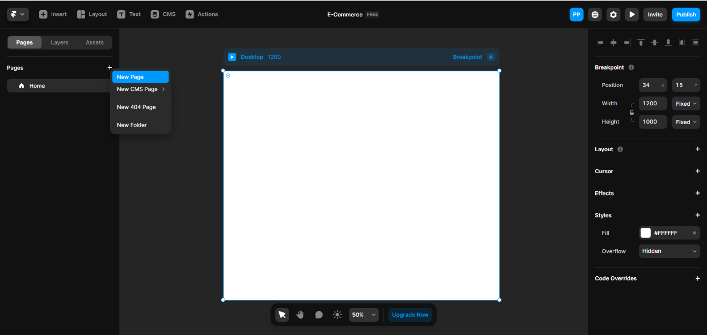

* 1. Name the new page as **Category** and press the **enter** key

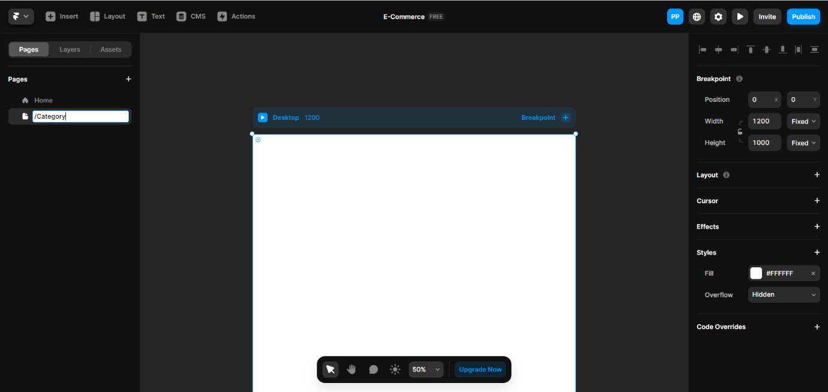

* 1. Create a page for **Product Detail** as shown:

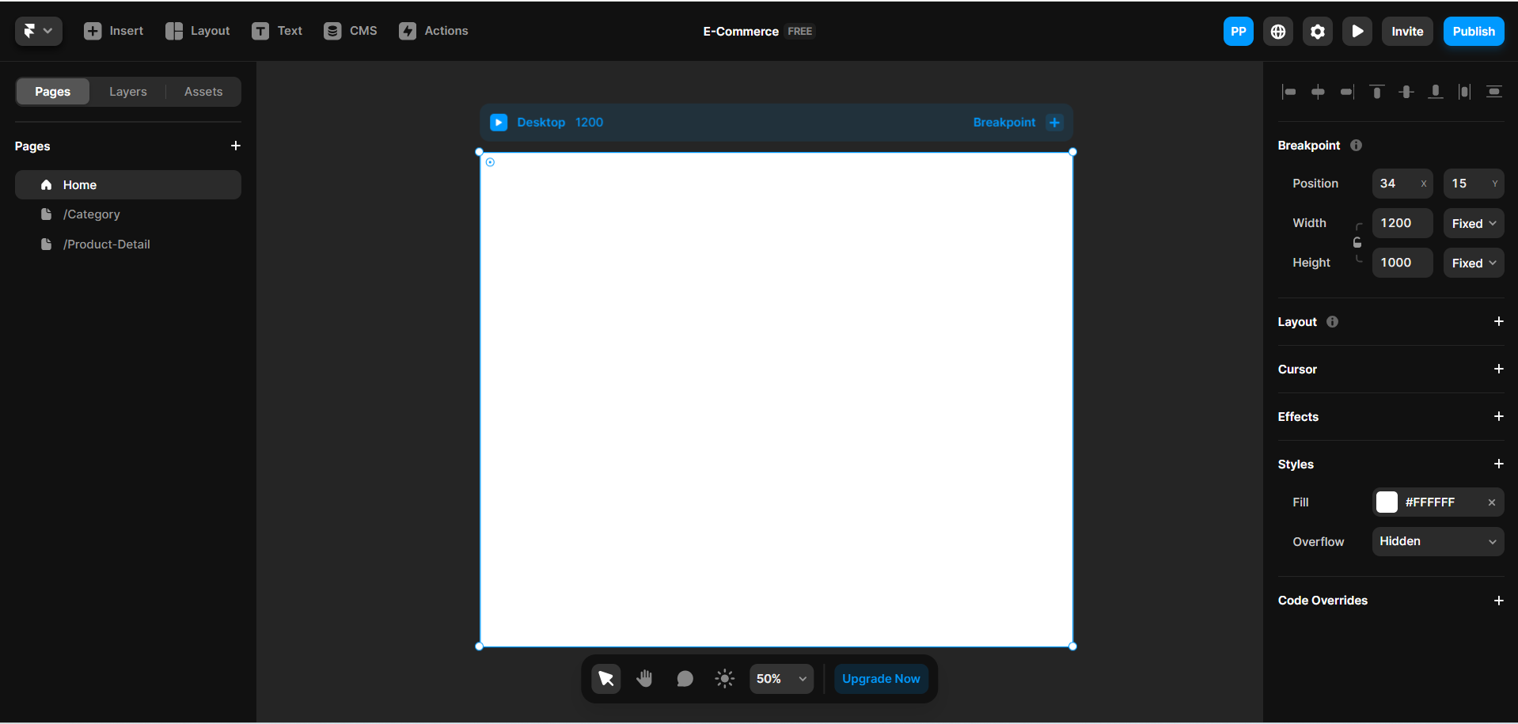

* 1. Navigate to the menu at the top left and select **Quick Actions**

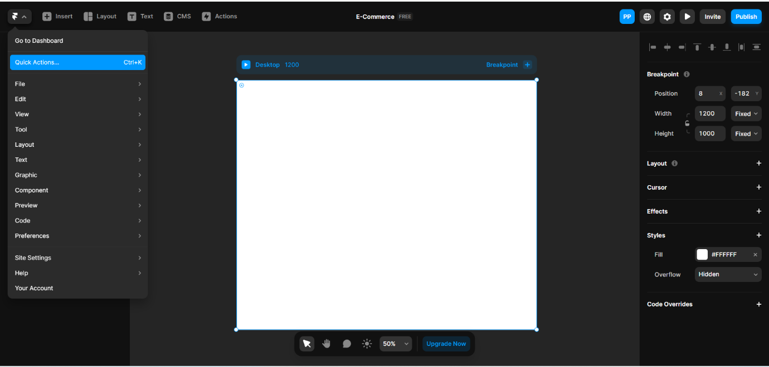

* 1. Click on **Generate Page** to automatically create an e-commerce webpage based on

the prompt

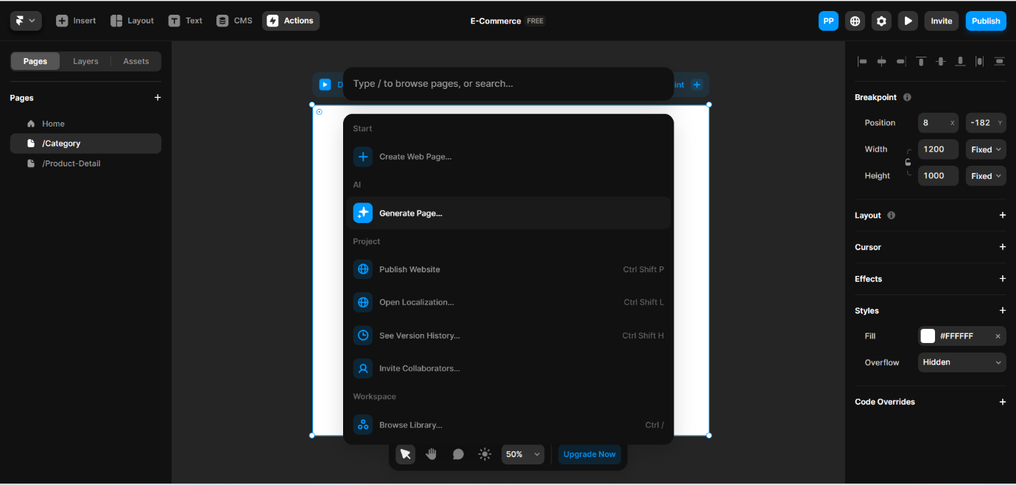

The prompt for generating web pages appears as follows:

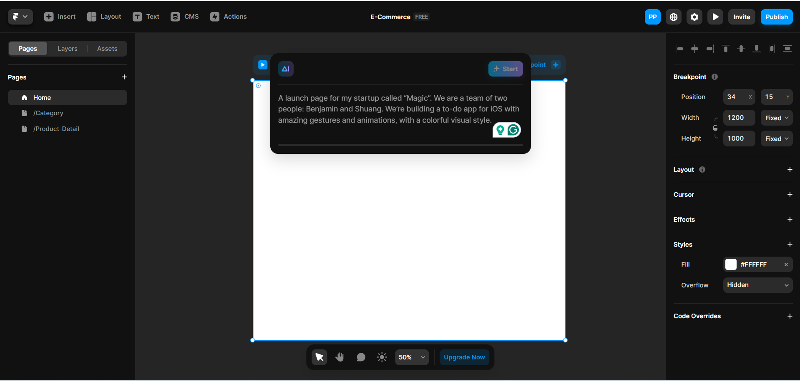

* 1. Use the following prompt to generate a **Home** page for Fresh Start Groceries   
      and then click on **Start**:

**Design the homepage for ‘****Fresh Start Groceries’ featuring a top navigation bar with the app logo and a prominent search field. Highlight ‘Featured Products’ in a carousel format, showcase ‘Categories’ with attractive icons, and present ‘Deals of the Day’ with a countdown timer. Include intuitive buttons like ‘Explore Fruits’ or ‘Browse Dairy’ that link to the respective sections on the Category Page.**

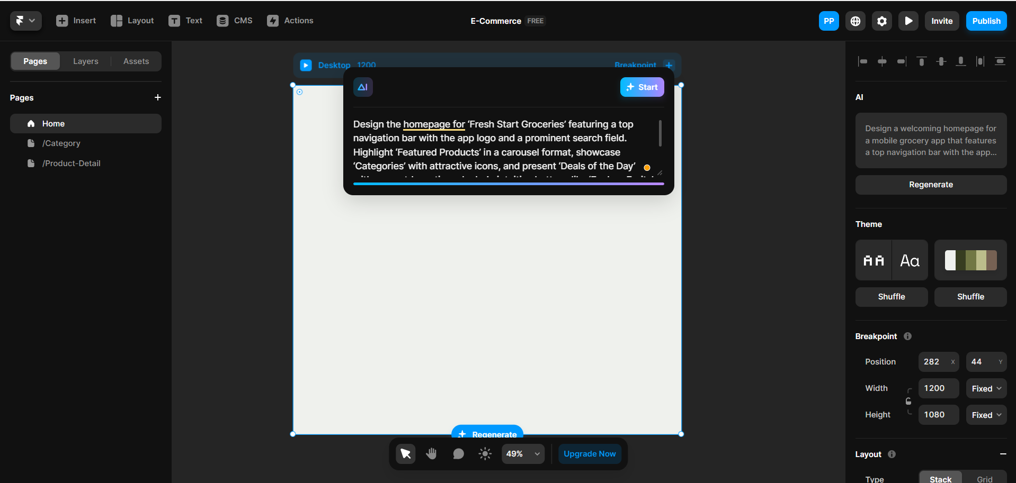

The progress of generating the webpage is as shown:

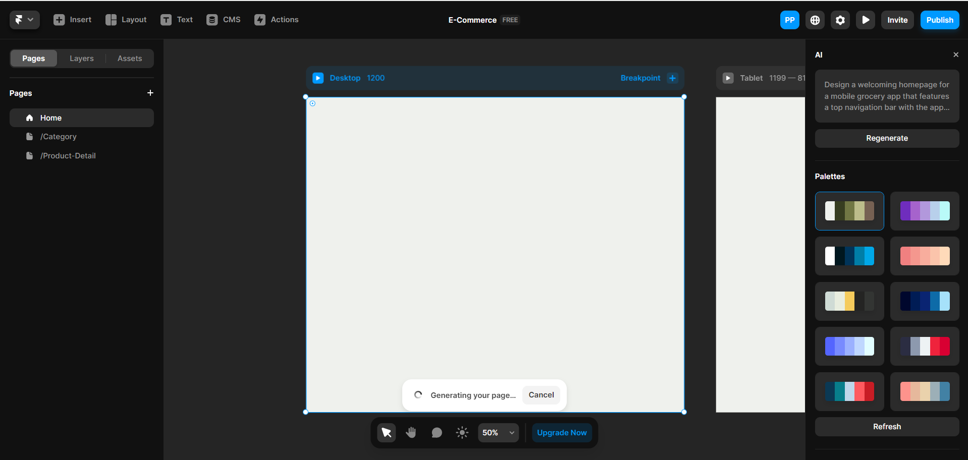

The following displays the generated e-commerce grocery Home page from the AI in desktop, tablet, and mobile views. Any changes made in one view will also reflect in the other views:

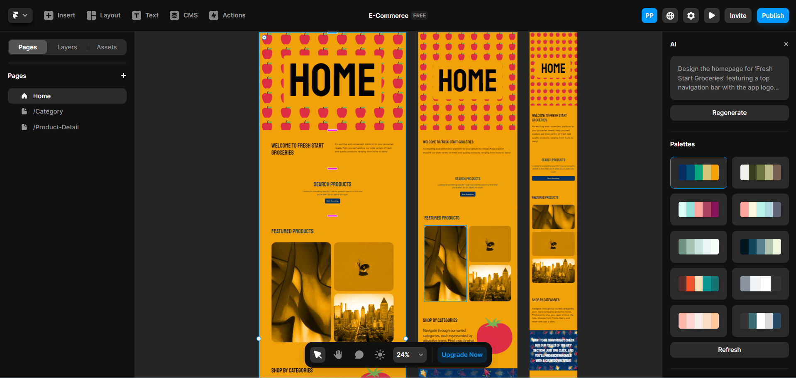

* 1. Click on the **Preview** button at the top right to preview the generated page

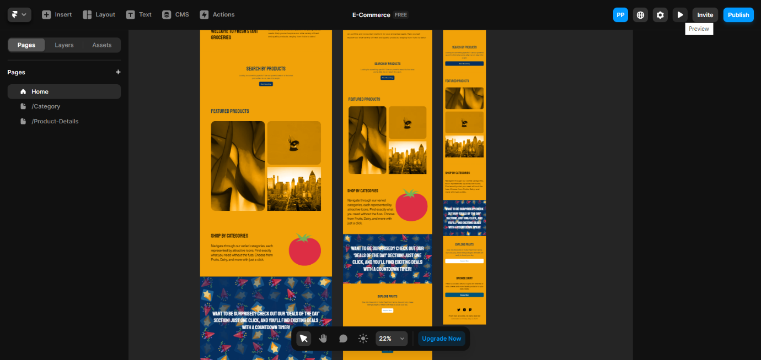

The generated **Home** page appears as follows:

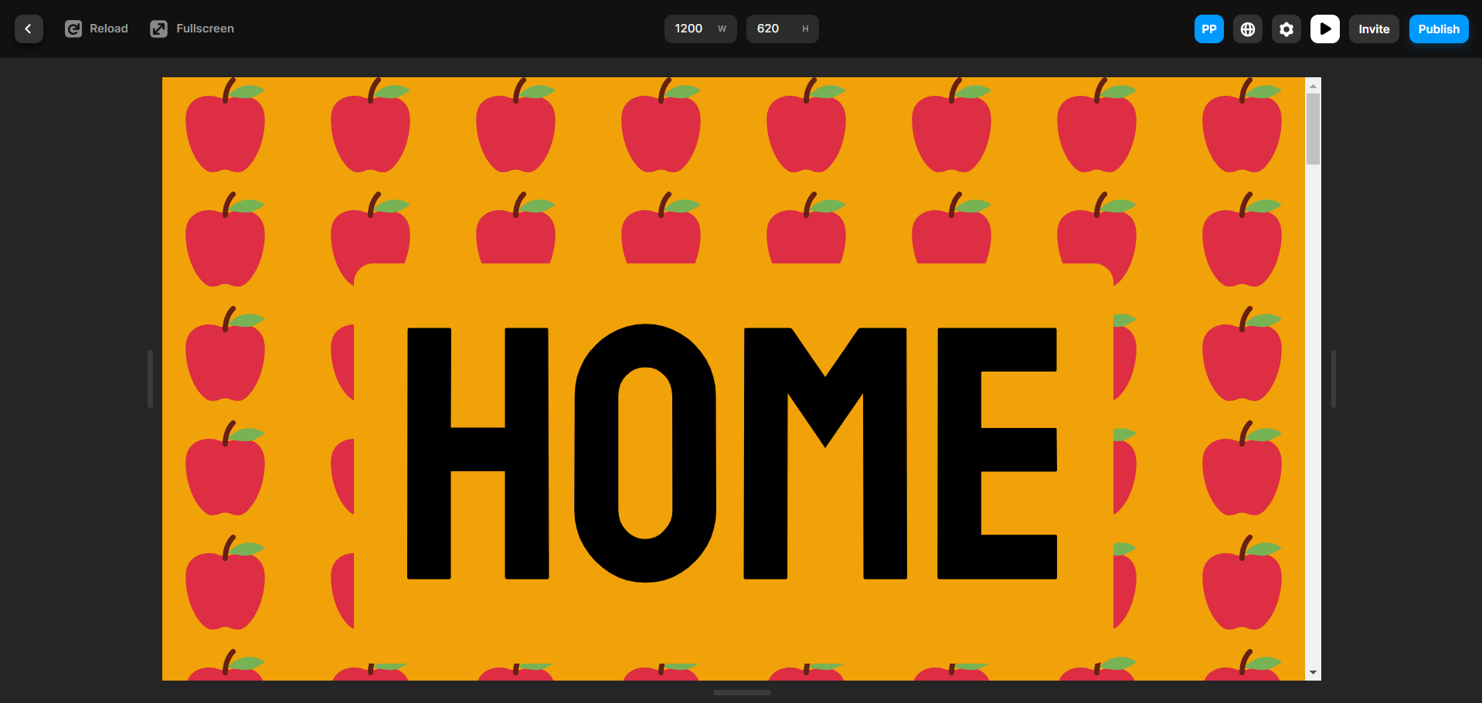

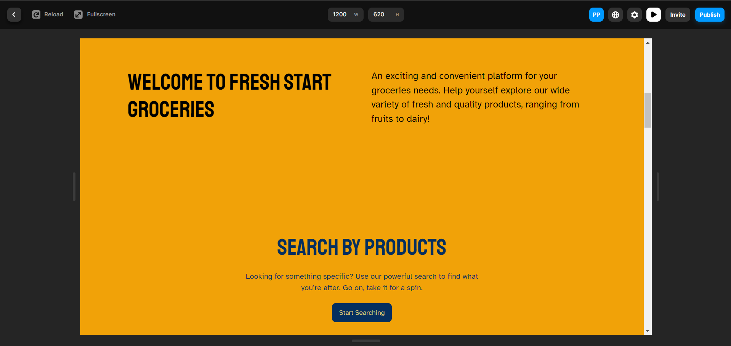

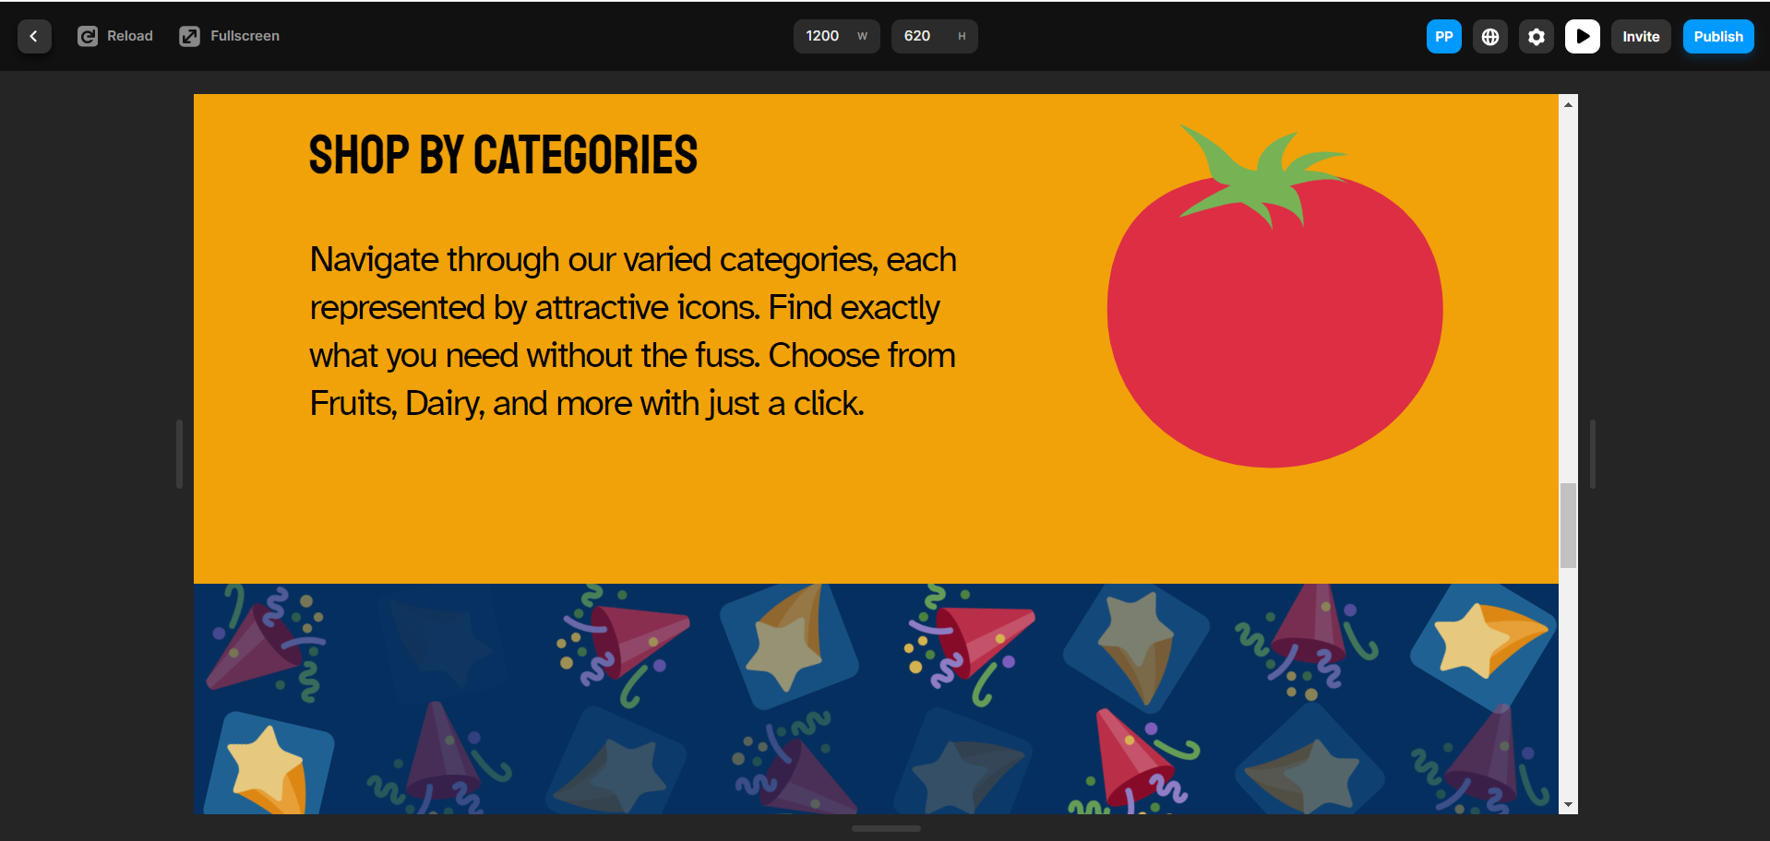

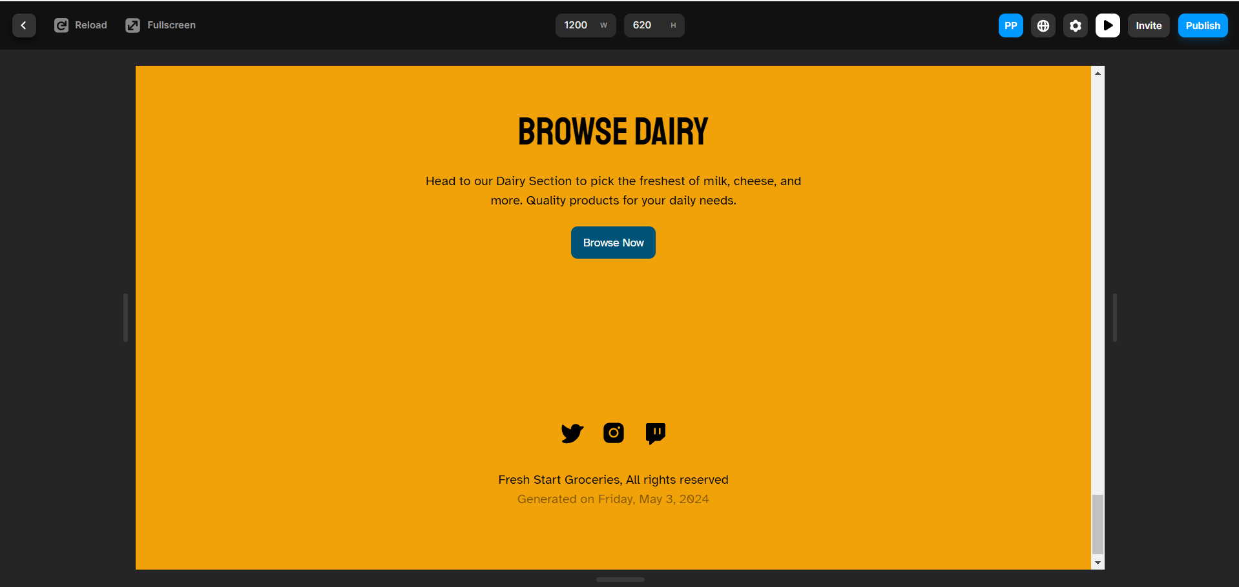

* 1. Click on the **Category** page and use the following prompt to generate the   
      webpage and then click on **Start**:

**Create the ‘Explore Selections’ category page for ‘Fresh Start Groceries’ displaying items in sections like Fruits, Vegetables, Dairy, Meats, and Snacks. Use a grid layout with representative icons for each section. Add a ‘See Details’ button under each category that leads to a pre-selected Product Detail Page, showcasing a popular item from that category.**

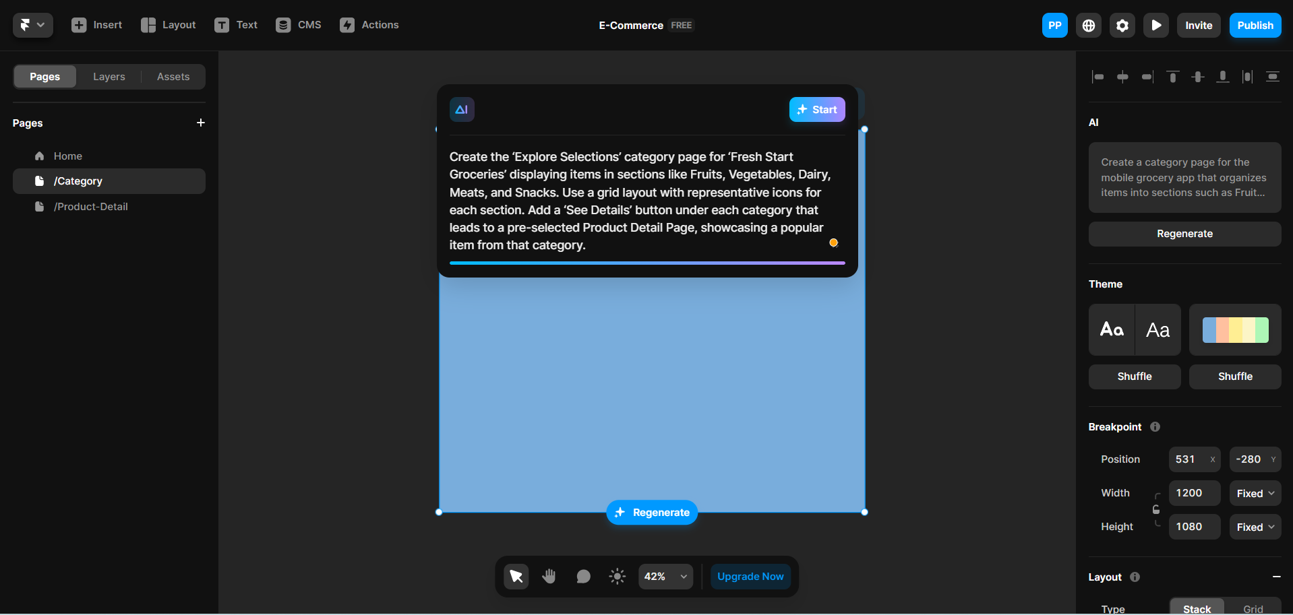

It generates the **Category** page of grocery products as follows:

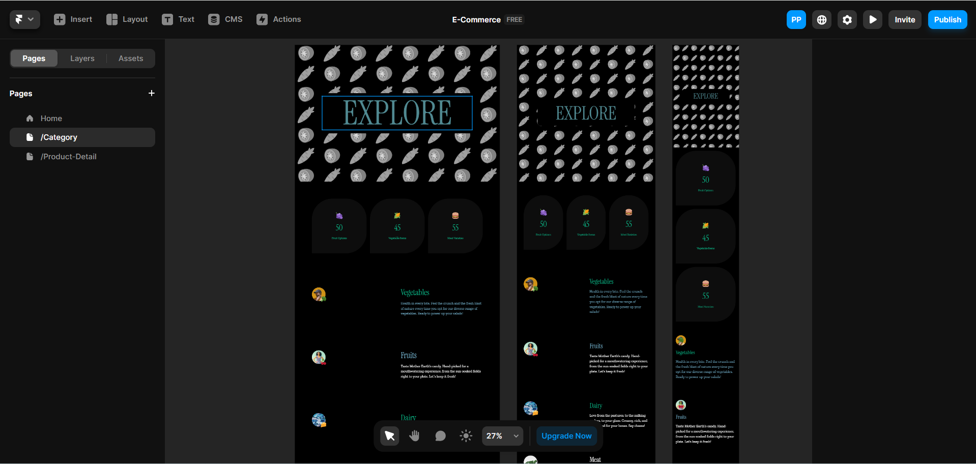

* 1. Select the **Product Detail** page and use the following prompt to generate

product details for the grocery and then click on **Start**:

**Generate the ‘Item Spotlight’ product detail page for a highlighted item in ‘Fresh Start Groceries’. Display a large item image, a detailed description, price information, and an ‘Add to Cart’ button. Ensure there’s a ‘Back to Categories’ link that navigates users back to the ‘Explore Selections’ page.**

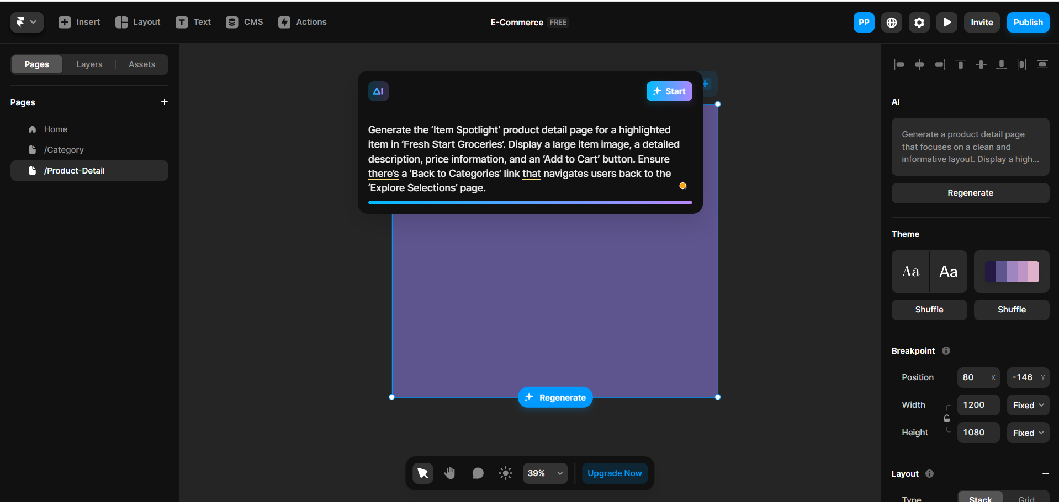

It generates the following pages:

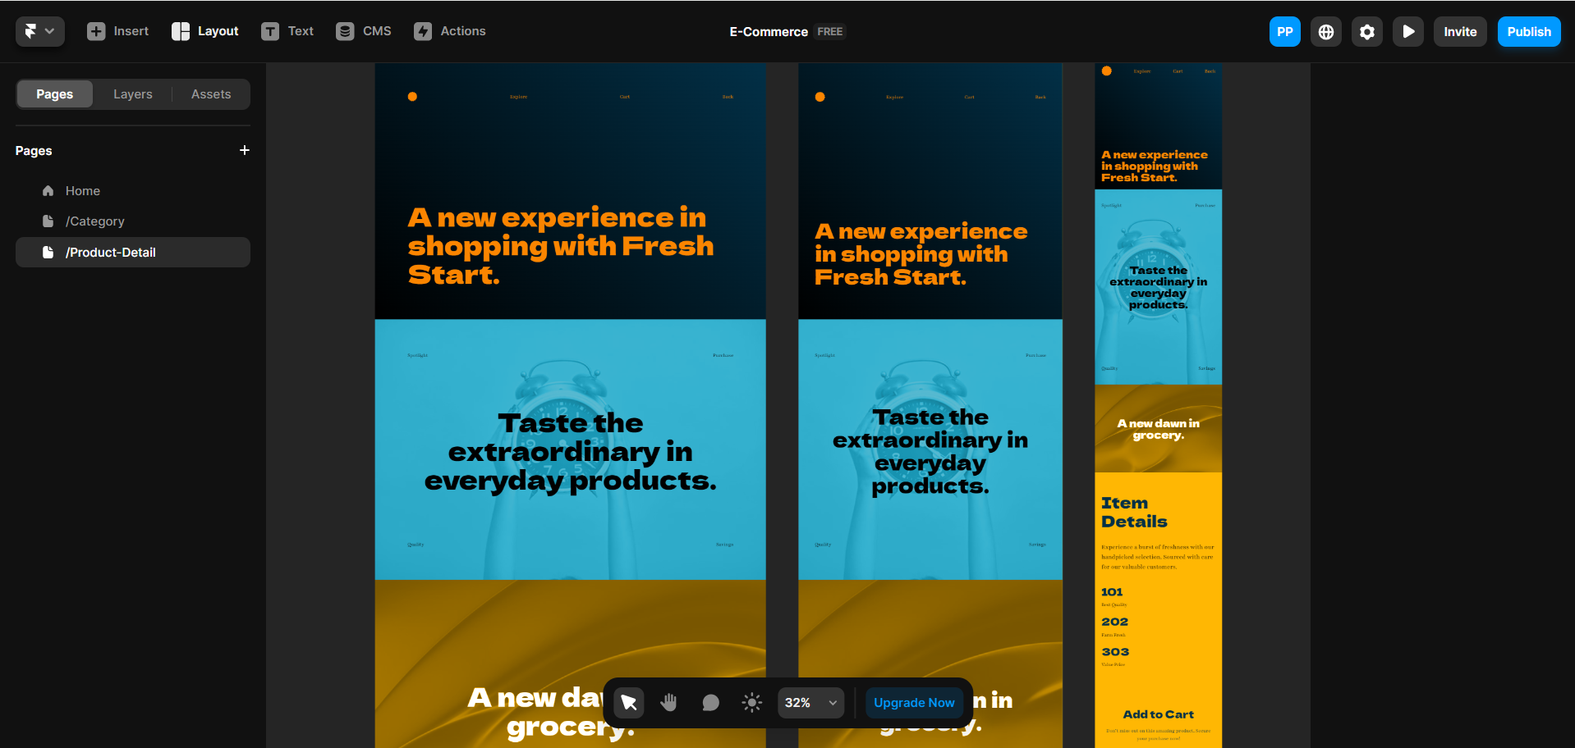

**Step 2: Enhance UI design for the generated page**

* 1. Link the **Home** page to the **Category** page. Select **SHOP BY CATEGORIES** from

the **Home** page and then click on the **+** icon on the **Link**

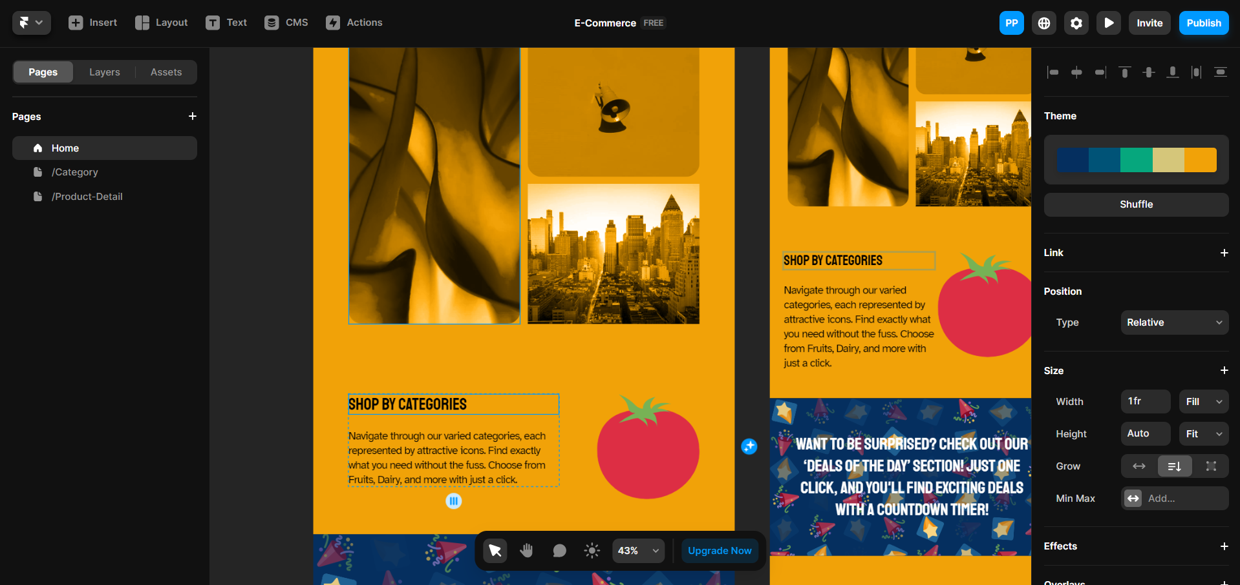

* 1. Select **/Category** from the list.

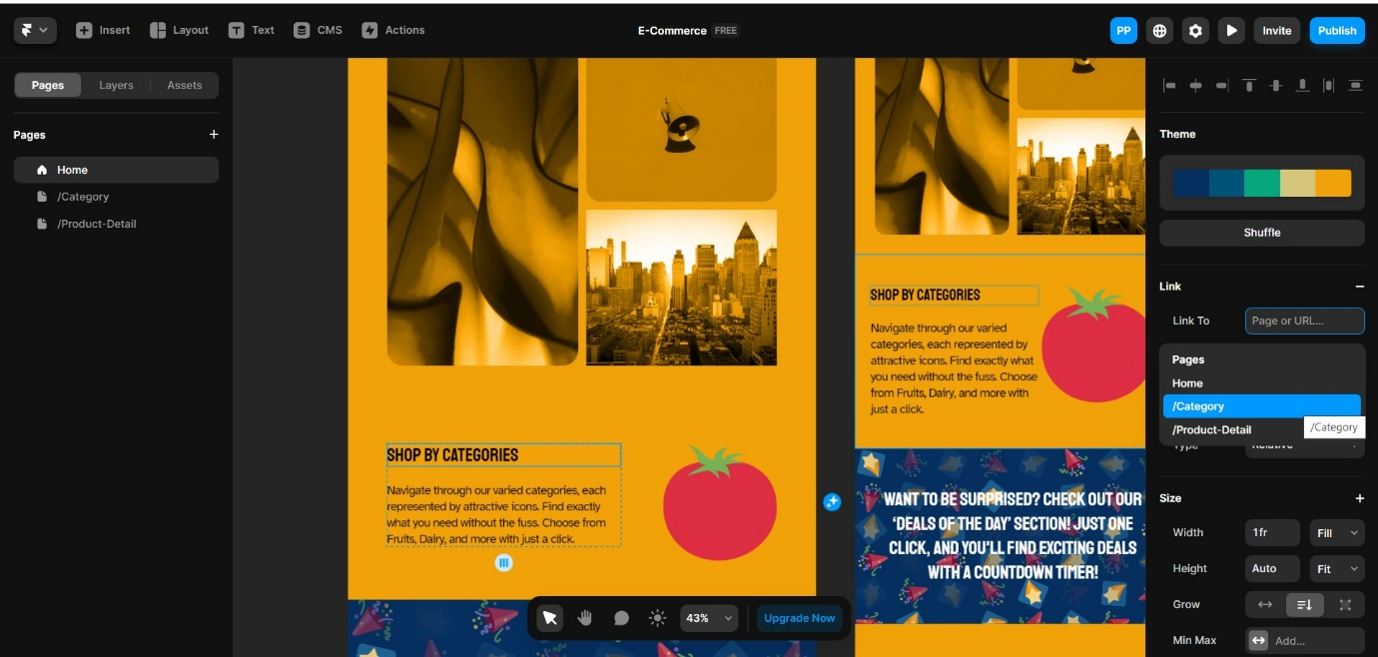

* 1. Click on the **Preview** button at the top right to preview the generated page

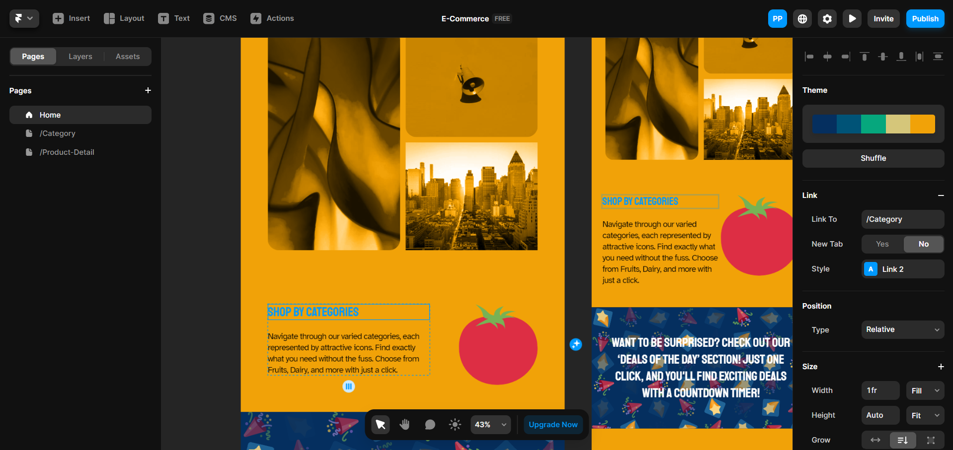

The page appears as follows:

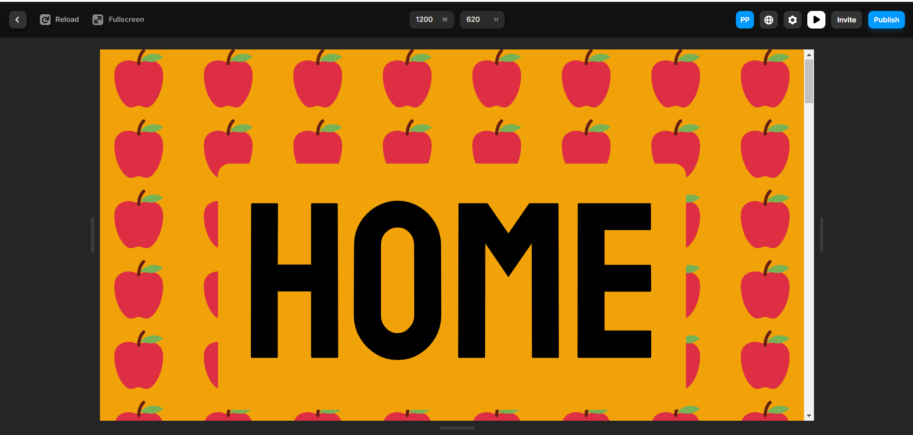

* 1. Scroll down the page and click on **SHOP BY CATEGORIES**

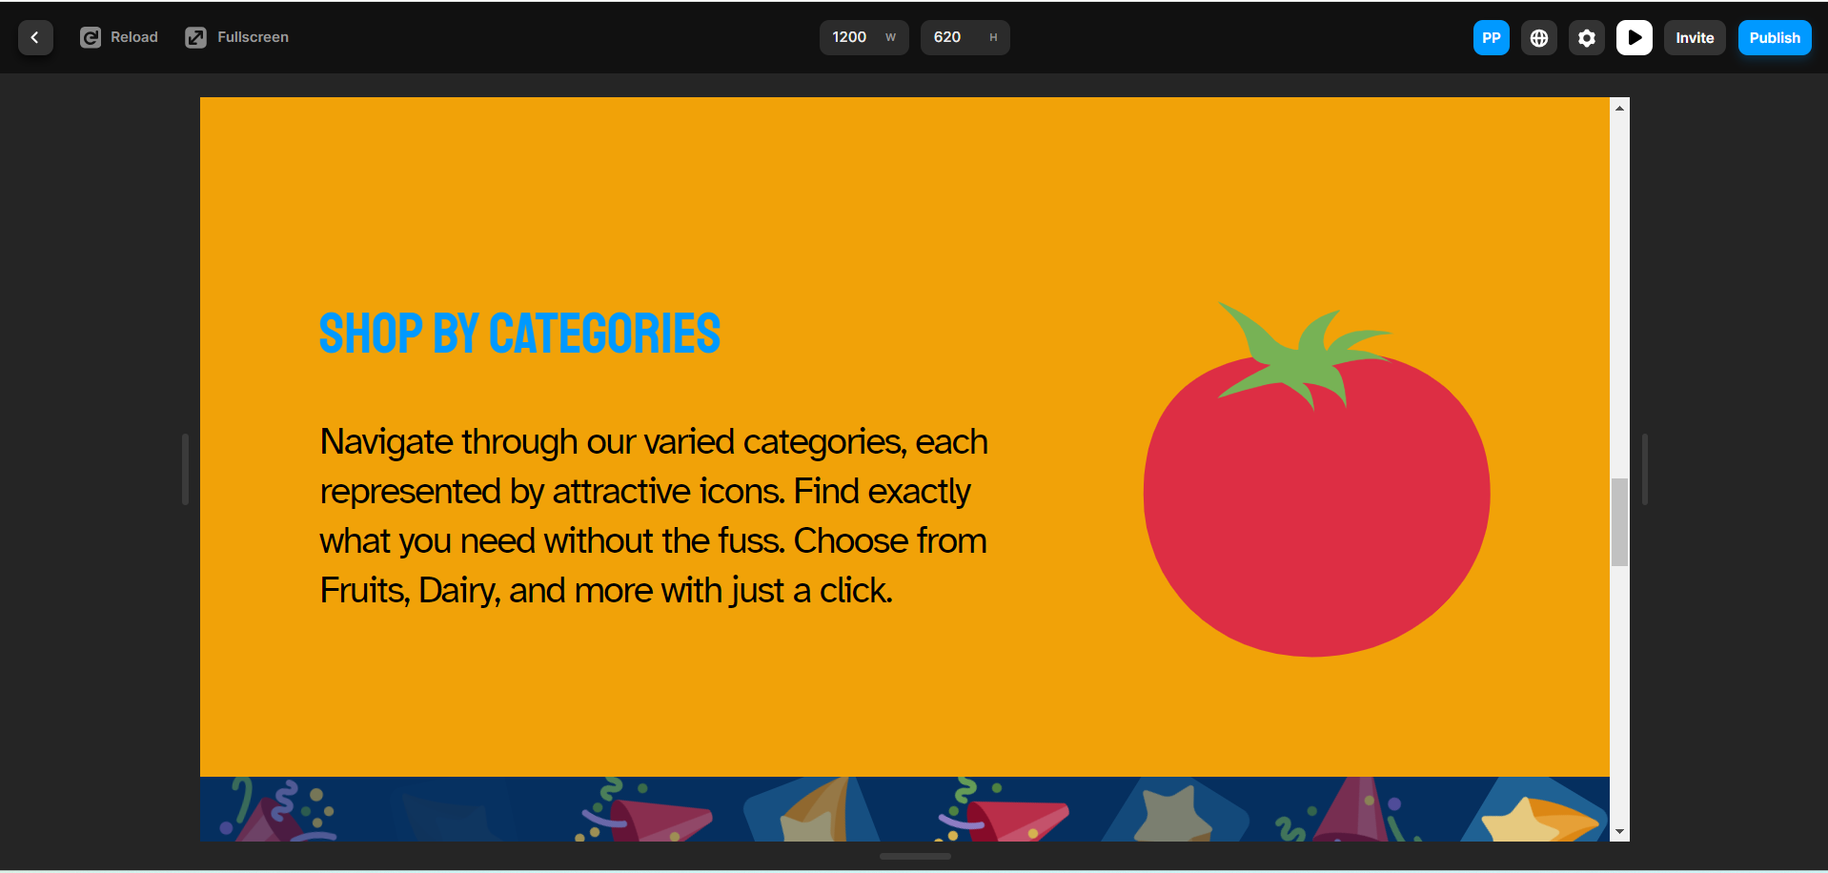

It navigates to the **Category** page.

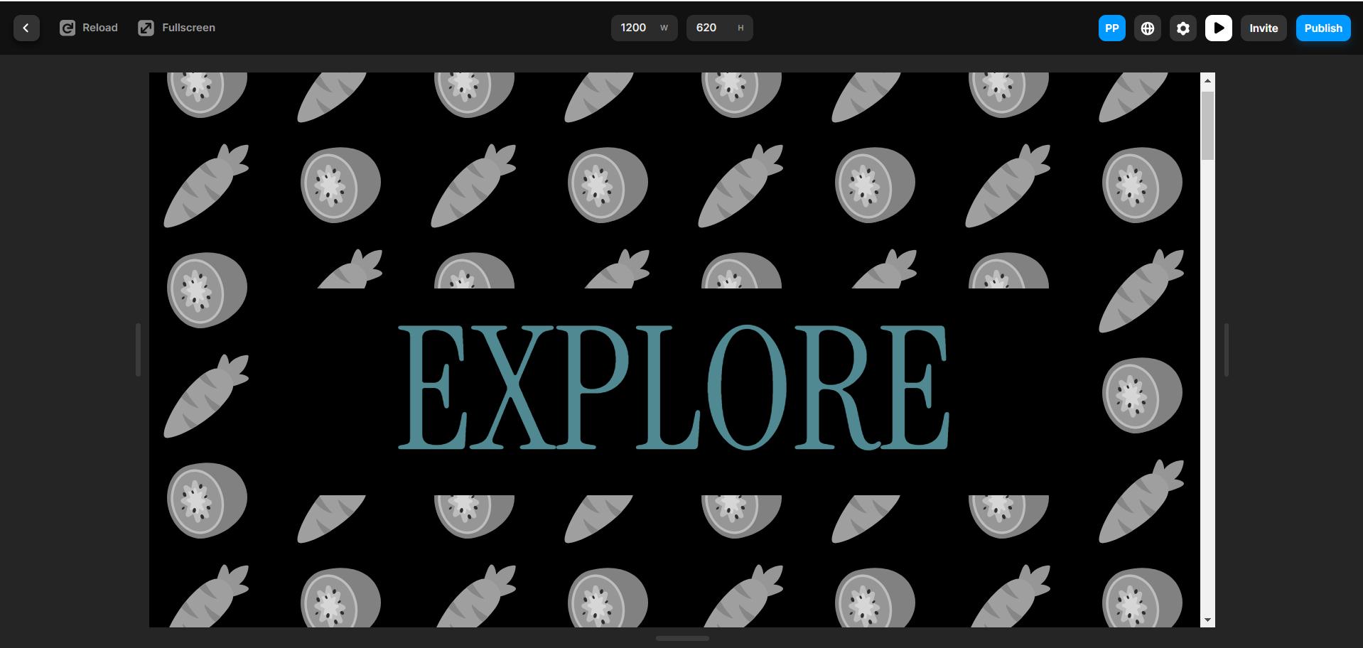

* 1. Select the **Home** page in the pages and then click on **Layers**. Expand **Desktop** and

then **Call to Action**. Select **SEARCH PRODUCTS** and rename the text to **SEARCH BY  
PRODUCTS**

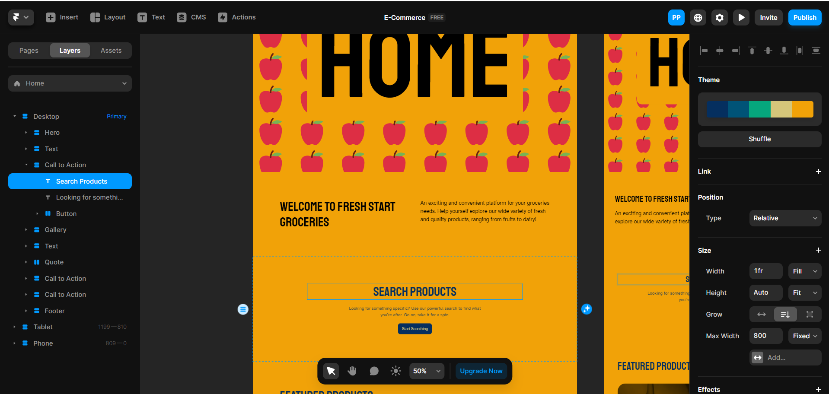

After changing the text, the **Home** page appears as follows:

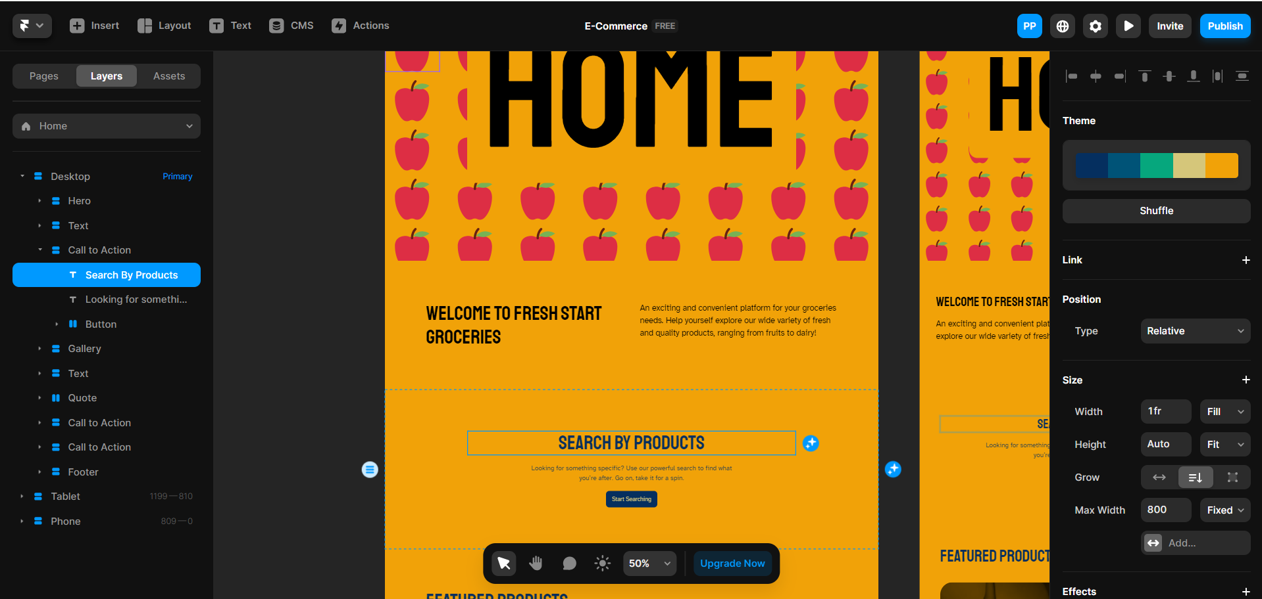

* 1. Expand **Gallery** and **Stack**. It consists of two rows, Row A and Row B. Select an image   
      under Row A and change it by uploading a new one. Click on **Choose Image** to   
      proceed as shown:

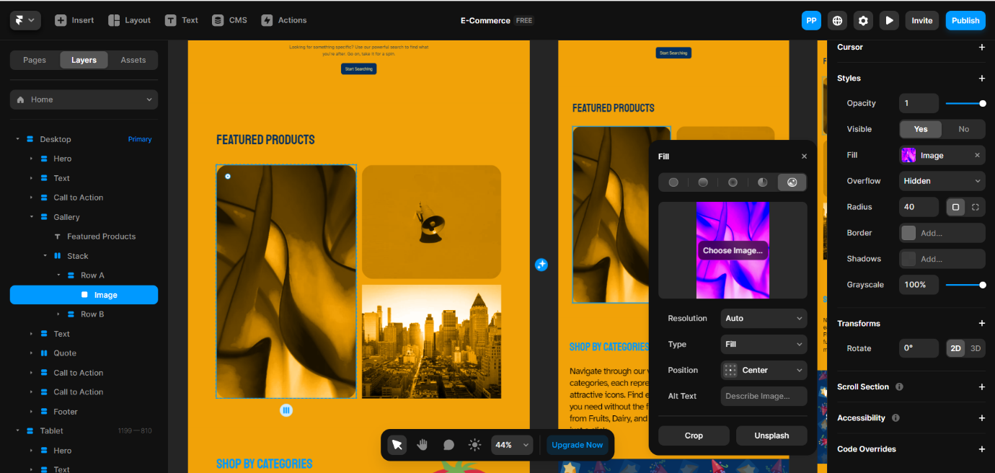

You will see the following interface:

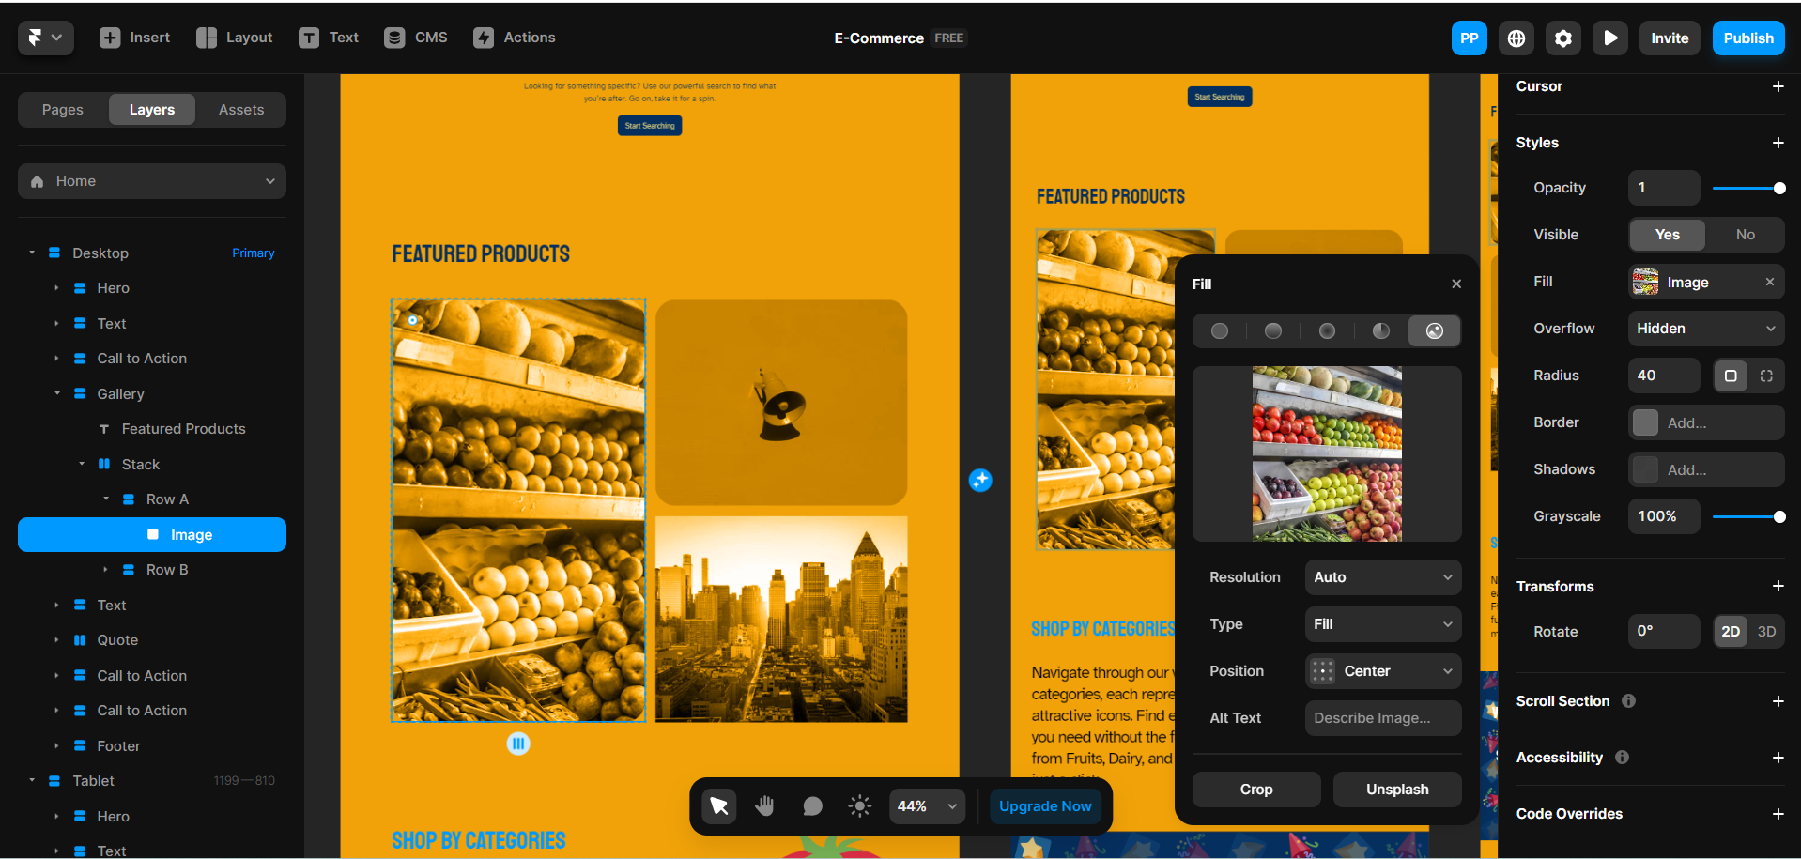

* 1. Click on **Publish** at the top right corner, select the link, and click on **Update** if the   
      Framer project was previously published

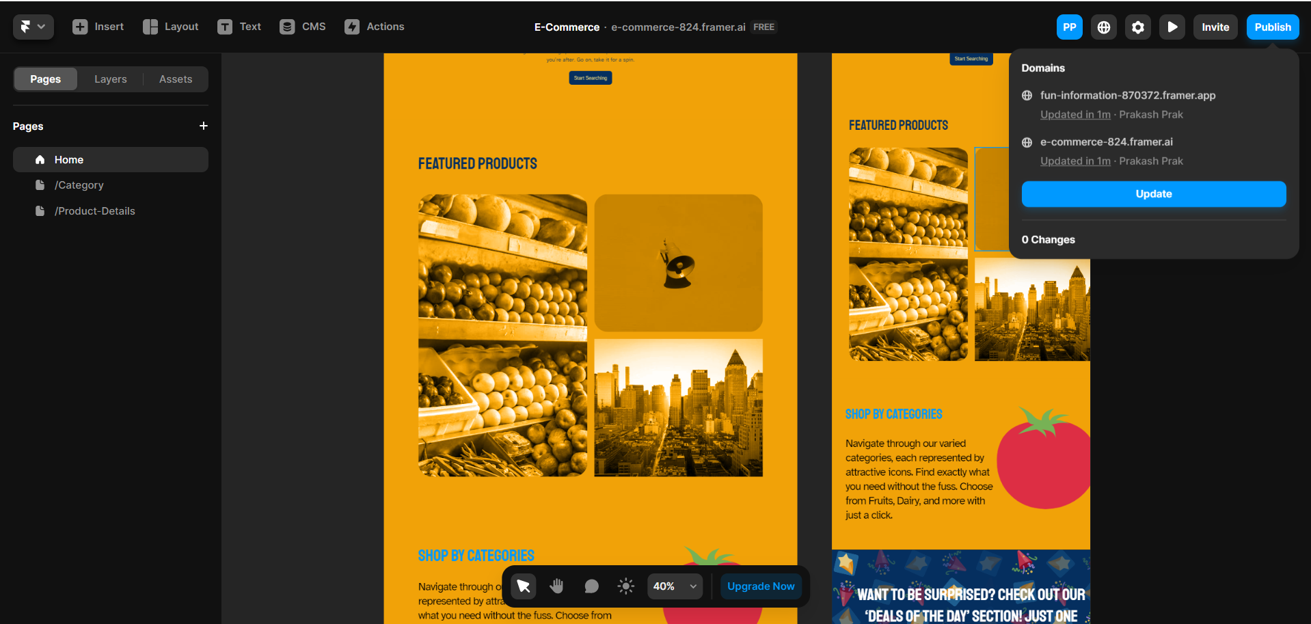

The website is now available to others upon publication.

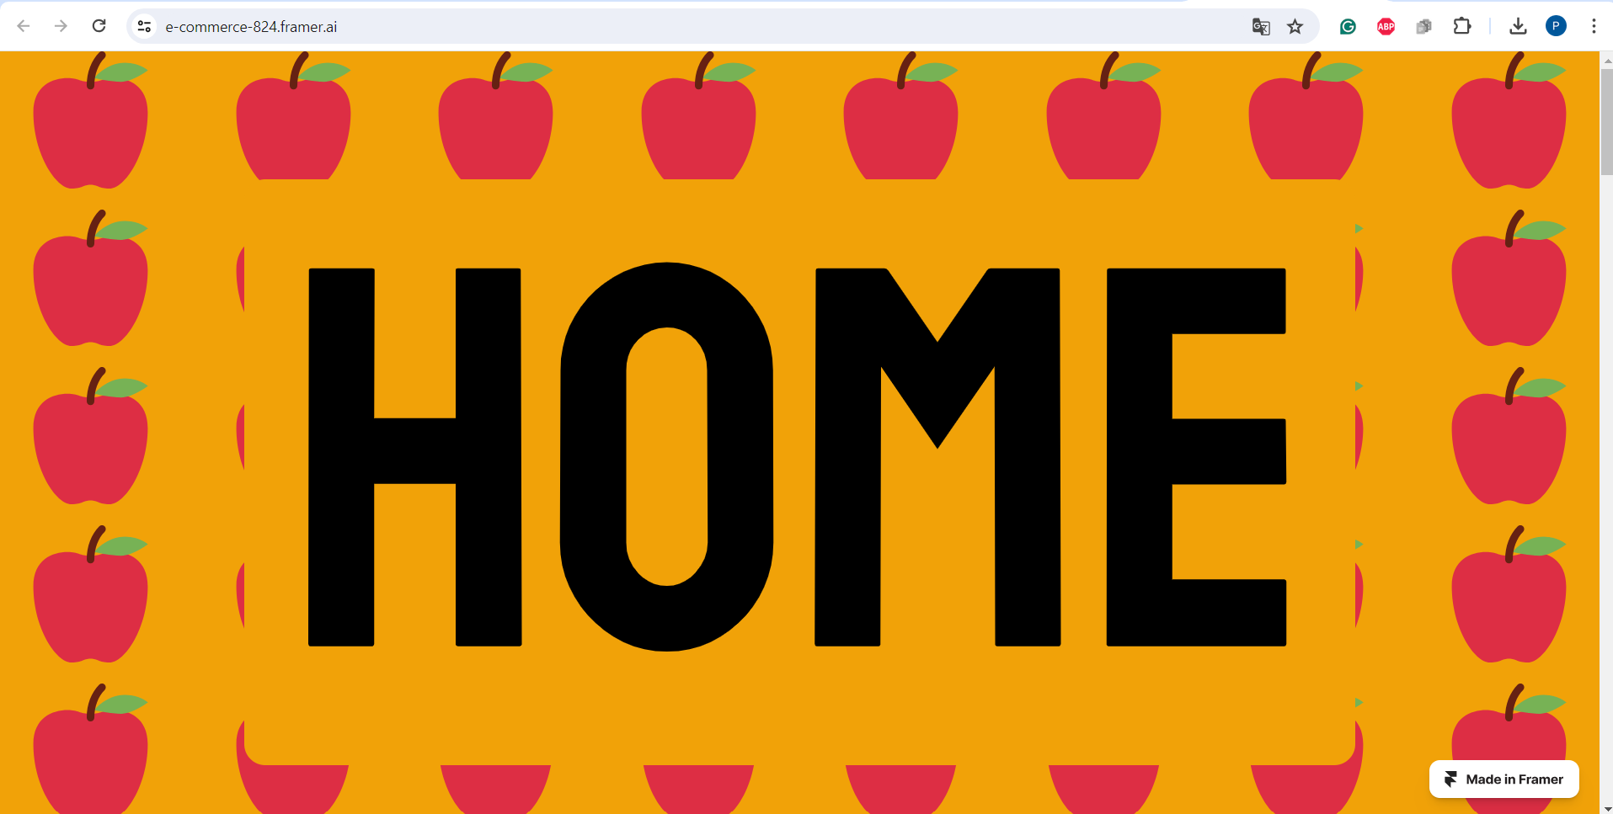

* 1. Scroll down and click on **SHOP BY CATEGORIES**

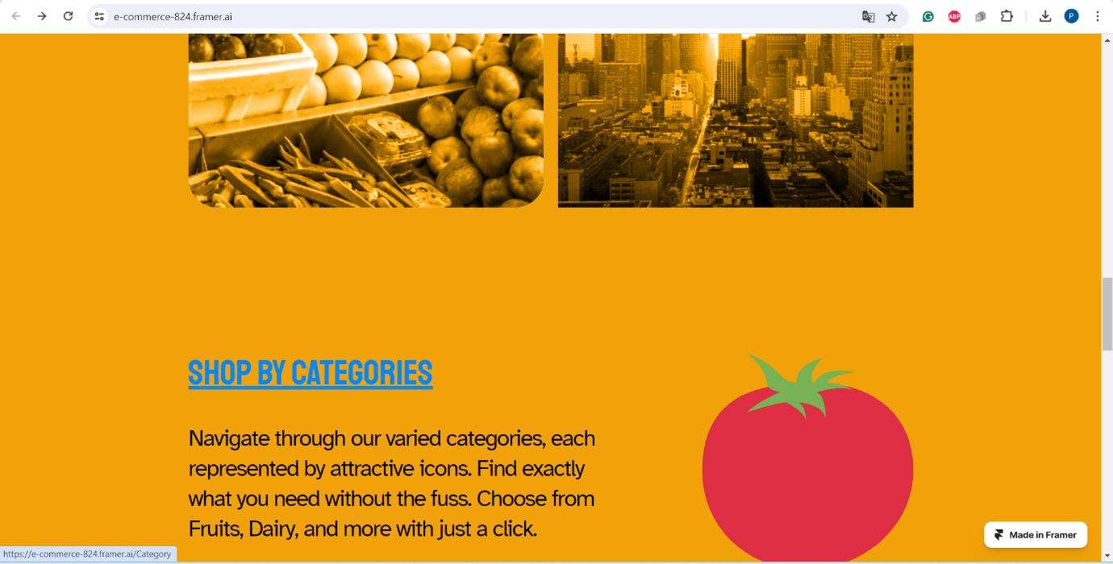

It directs you to the category page.

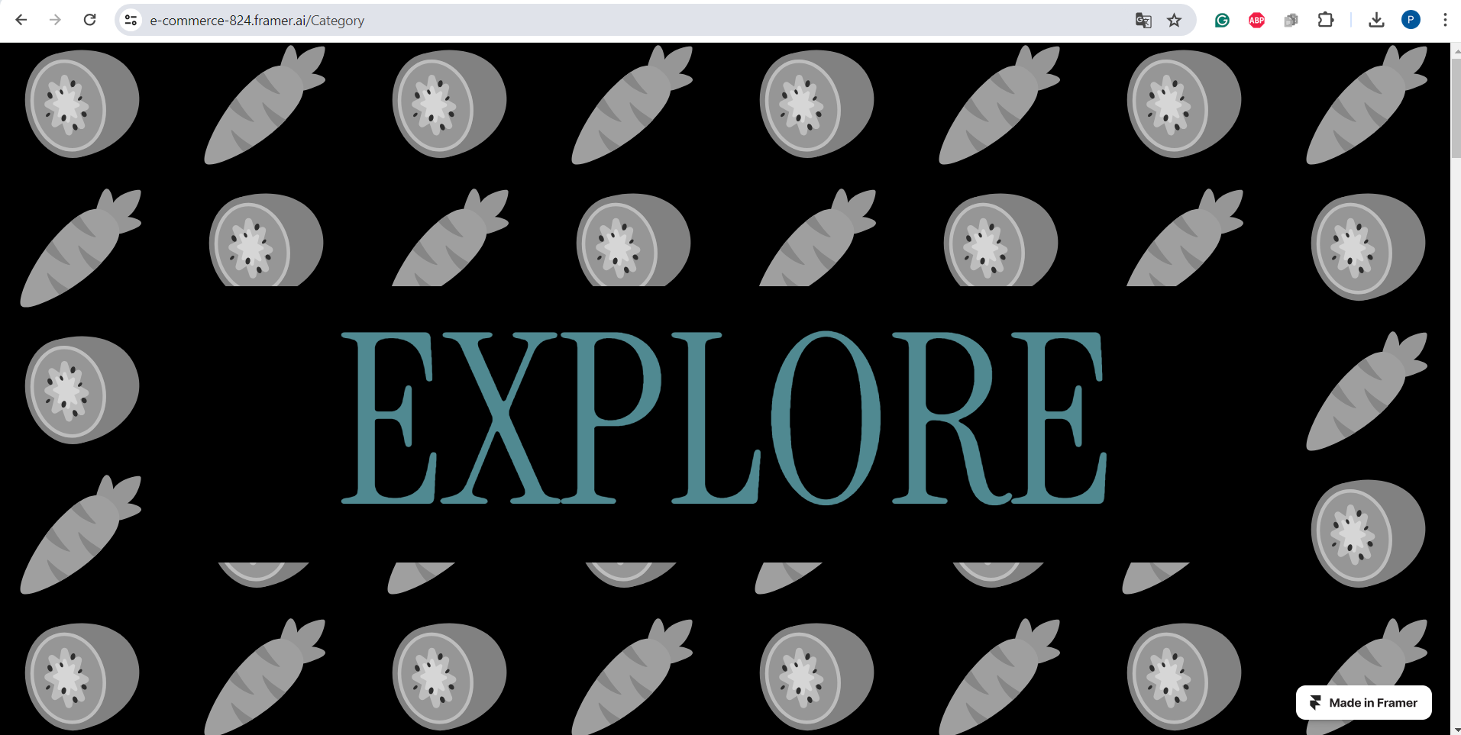

By completing these steps, you have successfully utilized Framer to efficiently prototype and visualize web designs for an e-commerce website.